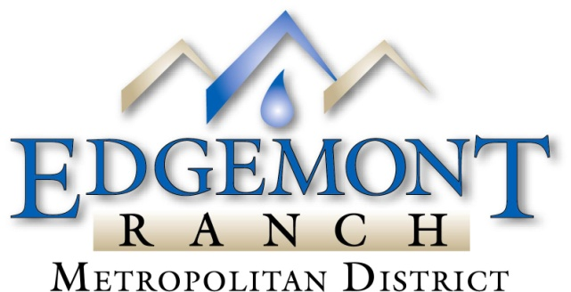

5972 County Road 234 Durango, CO 81301
Phone: 970-259-3102 Fax: 970-259-9870

NOTICE OF REGULAR MEETING OF THE EDGEMONT RANCH METROPOLITAN DISTRICT
BOARD OF DIRECTORS

TO ALL QUALIFIED TAXPAYING ELECTORS OF EDGEMONT RANCH METROPOLITAN DISTRICT TO ALL OTHER PERSONS TO WHOM IT MAY BE OF CONCERN:

NOTICE IS HEREBY GIVEN the Regular Meeting of the Edgemont Ranch Metropolitan District Board of Directors will be held at 4:00 PM on Thursday, October 16, 2025 at 5972 CR 234, Durango, Colorado.

The purpose of the meeting is to transact the items specified below and transact such other business as may properly come before the Board in accordance with the Bylaws of the District.

AGENDA ITEMS:

- Approve ERMD Regular Board Meeting Minutes from August 21, 2025
- 2024 Audit Report
- 3rd Quarter Financial Report - Marilyn
- Preliminary Budget Review for 2026 – Marilyn
4. Public Hearing and Consideration of Water Tier Rates Increase – Mr. Iwanicki
5. Consideration of Delinquent Accounts - Marilyn
6. Staff Report
A) Waste Water Plant Update – Mr Kurtis Martinez
B) Water Update – Mr. Ludwig
7. Board Concerns

Dated this 13th day of October, 2025

EDGEMONT RANCH METROPOLITAN DISTRICT
Marlena deCarion, President

5 Edgemont Ranch Metropolitan District Locations & La Plata County Clerk’s Office

